Program 8

Input:

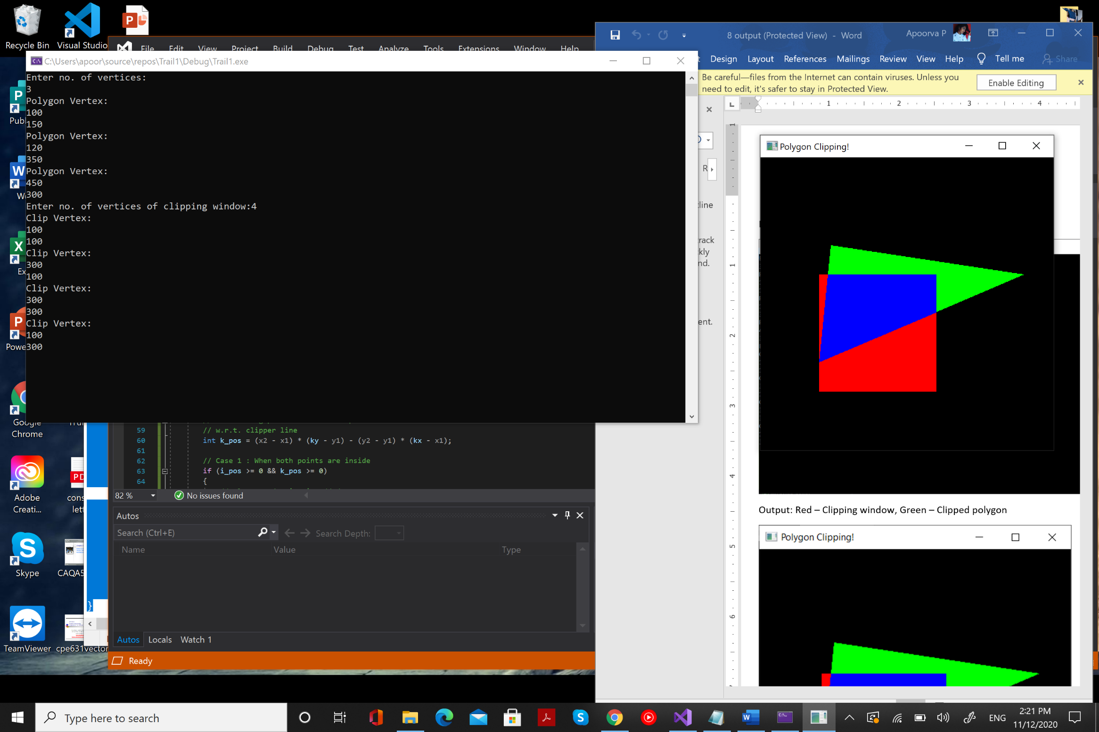

Output: Red – Clipping window, Green – Clipped polygon

